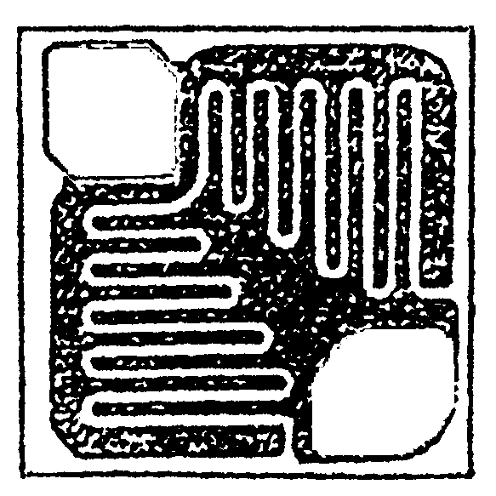

Top Material: Al
Backside Material: Gold
Bond Pad Size: .004 x .004”
Backside Potential: Collector
Mask Ref:
APPROVED BY: JK DIE SIZE : .022” x .022” DATE: 10/4/21
MFG: MICROSEMI THICKNESS: .015” P/N: 2N3250
DG 10.1.2

Rev B, 7/19/02

